**LED:**

Solid-state lighting businesses have advanced quickly over the years in both developing new ideas and enhancing the functionality of current light-emitting diodes (LEDs).This was because LEDs were more acceptable than incandescent and compact fluorescent lights due to their improved thermal performance, longer lifespan, affordable price, dependability, and environmental friendliness.LEDs may now be integrated into increasingly intricate and rugged locations because to the ongoing downsizing of LED casings and rise in power densities. But as power densities rise and enclosures become smaller, heat dissipation problems frequently accompany them. As a result, a lot of heat builds up inside the device in addition to the LED overheating, which causes the device's thermal and brightness output performance to degrade. LEDs must have a dependable and efficient thermal management system to maintain their thermal and brightness output performance. Thermal interface materials (TIMs) are typically used at the bottom of LEDs as a medium that helps heat dissipate from LED's enclosure in order to alleviate LEDs' thermal management challenges. There are many types of commercially available TIMs, including polymer or silicone composite adhesives, thermal pads, thermal grease, thermal paste, phase transition materials, and thermal fluids.

Commercially available TIMs are constrained in their potential use for LED thermal management due to factors such as low thermal conductivity, high interface resistance, high conductance, high thickness, which typically cause stack up tolerance, and pump out, messy, and dry out of the materials when used. To achieve an efficient heat dissipation rate, researchers have recently focused more on producing TIMs with excellent thermal conductivity.Recently, solid thin film TIMs were created as an alternative to the already available commercial TIMs. The low hardness and high thermal conductivity metal or ceramics from Ag, Al, Cu, Zn, BN, AlN, SiC, MgO, Al2O3, SiO, or a combination of any two (B-AlN, Ag-ZnO, Mg-ZnO, Cu-Al2O3, MgO-SiC, or MgO/ZnO) were coated over a metal substrate to create the solid thin films. In order to create a composite material with a notable high thermal conductivity and a low surface roughness to ensure good contact conductance between an LED enclosure and a heat sink, thin films (TIMs) with optimum or low thickness are deposited over Al or Cu substrates [1].

An LED is a p-n junction, where the current is injected in the forward bias and p-type and n-type materials are brought together. Then, the holes on the p-side and the uncompensated acceptors on the n-side will diffuse to the opposite side, leaving behind the respective electrons and holes. An electric field will develop in the transition (depletion) area as more carriers diffuse, blocking further diffusion. The potential difference between the n- and p-sides is known as the contact potential, and band bending takes place to maintain the Fermi level constant throughout the device.

The carrier diffusion caused by the concentration gradient and the carrier drift caused by the electrical field in the transition zone cancel each other out when the junction is in equilibrium, producing no net current. In the neutral (depletion) region of the p-n junction, e- and h+ recombinations take place as current is transmitted through the device in forward bias. In a direct band gap semiconductor, excited electrons and holes combine and release energy by producing photons. The hue of the emitted light will match the band gap energy [2]. ZnO is well suited for LED technology because electrons and holes generate tightly bound excitons, which facilitate near-band gap recombinations at ambient temperature. Very active optical characteristics can be seen in ZnO nanostructure.

The defect states present in the nanostructures are related with higher UV emission and dry low emission in the visible region in the photoluminescence (PL) spectra of ZnO. Light is emitted in the visible spectrum when transitions through defect states take place, and emission at various wavelengths occurs from transitions from distinct defect states. There have been reports on ZnO sheets emitting green, red, and blue light [3]. However, the intensity of the emission must be quite high to be taken into account for device applications. By externally doping the ZnO host lattice with dopants, the strong emission can be produced.

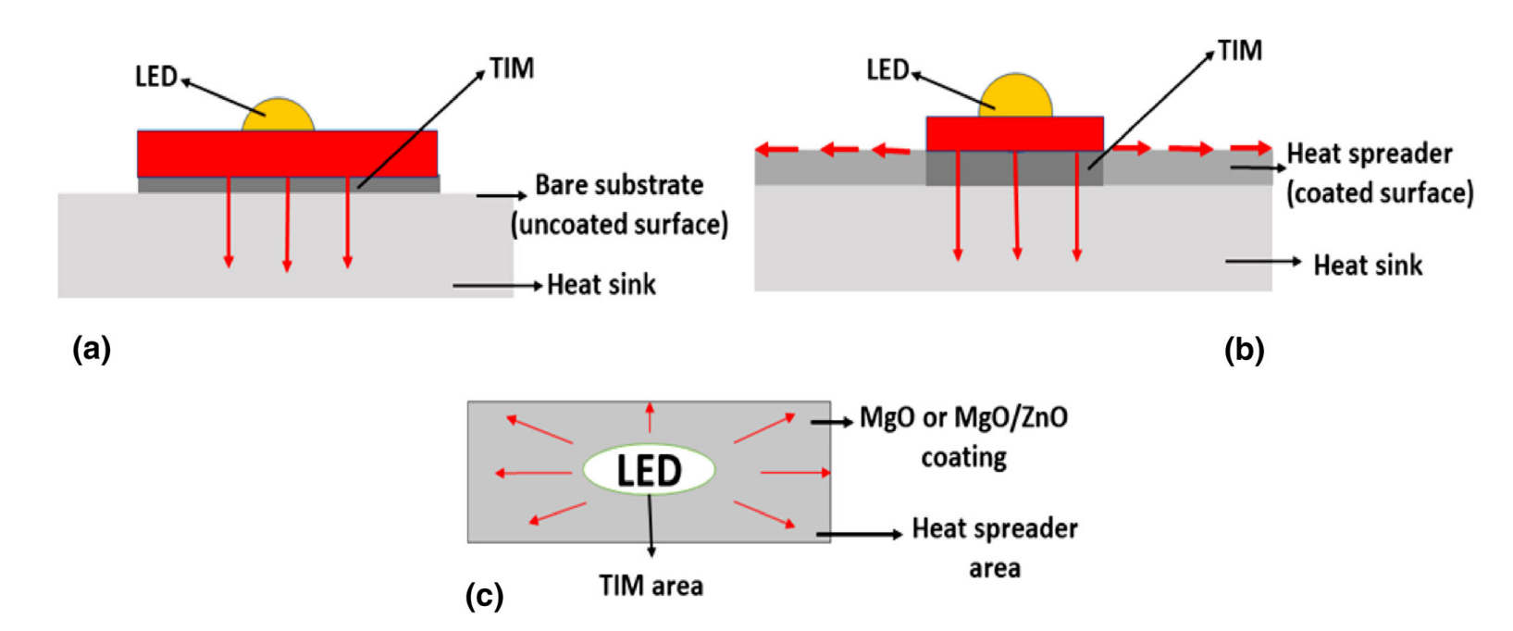

**Fig.** illustration of LED mounted on TIM and showing heat dissipation via (a) the TIM only, (b) the TIM and through the in-plane direction (coated and exposed area to the ambient), (c) top view of (b) [1].

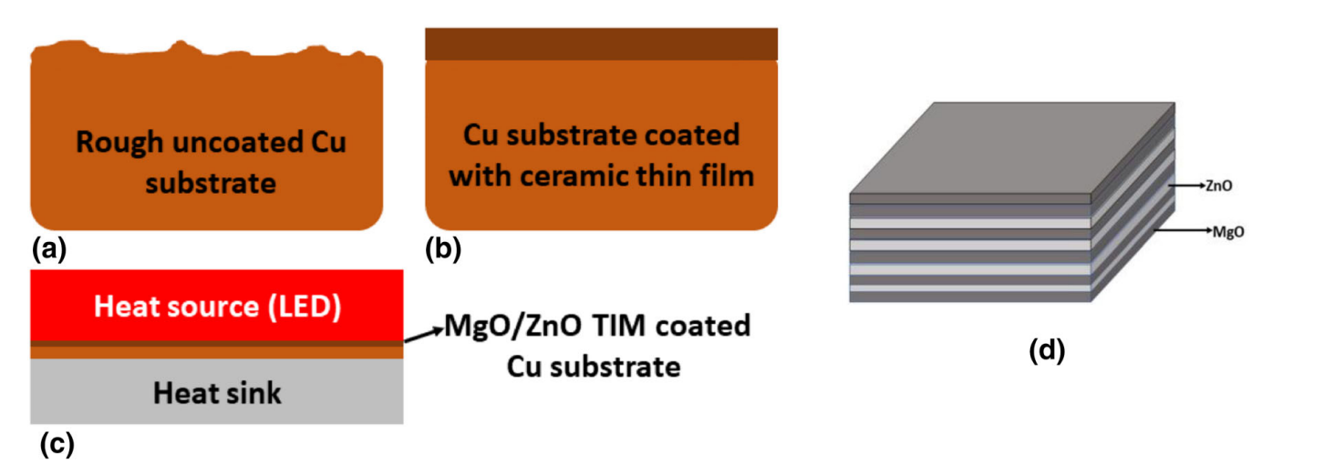

**Fig:** Illustration of (a) uncoated Cu substrate, (b) MgO/ZnO TIM coated over Cu substrate and (c) sandwiched between high power LED and heat sink to eliminate air gaps created due to their respective rough surfaces and (d) An illustration of stacking of MgO and ZnO layers [1].